CHAPTER 1
Optimising Recency-Weighted Cycle Forecasting and Confidence Calibration in SheSync, a Mobile Menstrual Health Application
Vyom Varshney¹*, Vishal Gupta¹, Shivangi Yadav¹, Vanshika Singh¹
¹Department of Computer Science and Engineering (Artificial Intelligence), ABES Institute of Technology, Ghaziabad, Uttar Pradesh, India, Email Id-vyomvarshney2005@gmail.com
Abstract: Period-tracking apps forecast the next period from a few past cycle lengths, yet the rule and the confidence they show are rarely validated. We treat the forecasting engine of SheSync, a cross-platform React Native application, as an optimisation problem. The deployed engine combines a recency-weighted mean of up to four cycles with hard questionnaire floors and shows a heuristic confidence. A Python re-implementation, verified against the shipped TypeScript code, was evaluated on 1,000 simulated users anchored to published app data, under stationary and drifting regimes. Grid search over the weights, a tuned shrinkage prior in place of the floors and binned recalibration lowered the mean absolute error on held-out users from 4.20 to 3.69 days (12.0%) for stationary cycles, from 3.94 to 3.58 days (9.1%) under drift and by 20.3% with one past cycle, and cut the expected calibration error from 31.6 to 3.6 points; weight tuning alone contributed little.
Keywords: Menstrual cycle forecasting, Recency weighting, Grid search, Shrinkage estimation, Confidence calibration, Mobile health.
INTRODUCTION
The predicted start of the next period is usually the first number a period-tracker user sees [1, 2]. Large app datasets show that the textbook 28-day cycle is the exception: across more than 600,000 cycles the mean length was 29.3 days and only about 13% lasted exactly 28 days [3], and over half of the users of a connected ovulation test had cycles varying by five days or more [4]. Long, irregular cycles are typical of polycystic ovary syndrome, which affects roughly 6–10% of women of reproductive age [5], exactly where guidance matters most.
SheSync, the authors’ Android, iOS and web application built with React Native and Expo, shows a predicted period, an ovulation window, a regularity class and a confidence percentage from a hand-designed TypeScript engine. We ask whether its weights are near optimal, whether its questionnaire floors help, and whether its displayed confidence is truthful, and propose changes evaluated on held-out users.
RELATED WORKS
Moglia et al. judged only 20 of 108 free tracking apps accurate, requiring predictions to average at least three cycles [6], and Worsfold et al. found that ten popular apps gave conflicting dates for the same histories [2]. Statistical models are richer: Guo et al. used a mixture distribution [7]; Bortot et al. let the mean cycle length follow a random walk [8], which also fitted athletes’ data best [9]; Li et al. characterised variability across millions of tracked cycles [10]; and Urteaga et al. obtained better-calibrated intervals with a generalised Poisson model [11]. We keep SheSync’s lightweight client-side structure but tune it with held-out error evaluation, empirical Bayes shrinkage [12] and the expected calibration error (ECE) [13].
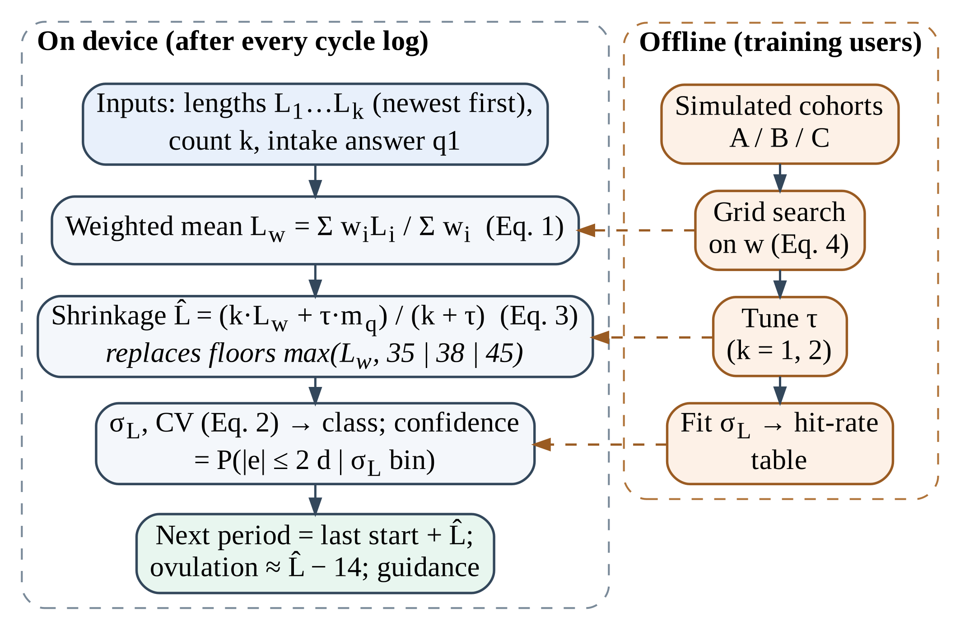
Figure 1. Forecasting path of SheSync with the proposed optimisation steps (left: on device; right: offline, training users only).
PROPOSED WORK
3.1 Deployed Forecasting Engine
SheSync converts logged period starts into cycle lengths L₁, L₂, … (most recent first), and the user states how many cycles she recalls, k ∈ {1, …, 4}. The engine computes
L_{w} = Σ_{i=1..k} w_{i}L_{i} / Σ_{i=1..k} w_{i}, w = (3, 2, 1.5, 1) (1)
rounded to whole days. Intake question q1 then imposes hard floors: “irregular” sets L̂ = max(L_{w}, 35), “longer than 35 days” max(L_{w}, 38) and “absent for 90 days” max(L_{w}, 45); “shorter than 24 days” caps it at 23. Dispersion is
σ_{L} = [ (1/k) Σ_{i} (L_{i} − L̂)² ]^{1/2}, CV = 100 σ_{L} / max(20, L̂) (2)
and (σ_{L}, CV, q1) select a class, regular, moderate or irregular, shown with a fixed confidence of 91–97%, 76–86% or 65–72%. The next period is placed L̂ days after the last start and ovulation 14 days earlier (Figs. 1 and 2).
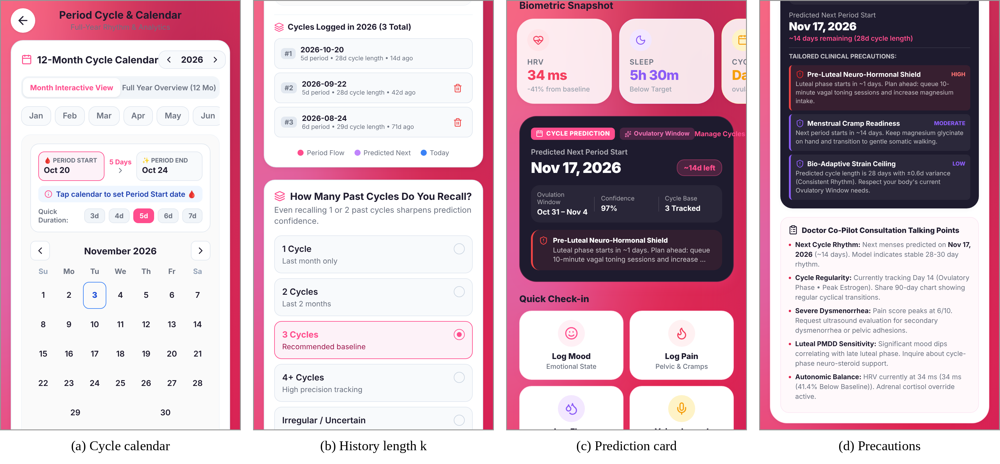
Figure 2. SheSync screens from the production web build: (a) 12-month cycle calendar, (b) choice of the number of recalled cycles k, (c) prediction card with displayed confidence, (d) phase-specific precautions.
3.2 Shrinkage Prior and Weight Optimisation
A hard floor treats the q1 answer as certain and ignores the logged cycles. We replace it with a prior mean m_{q} (29, 23, 40, 31 and 45 days for “consistent”, “short”, “long”, “irregular” and “absent”) of strength τ:
L̂ = (k·L_{w} + τ·m_{q}) / (k + τ) (3)
so the prior dominates with little history and the data take over as cycles accumulate [12]. The weights minimise the error of the rounded forecast on training users,
w* = arg min_{w ∈ Δ} (1/N) Σ_{n} | round(L_{w}(H_{n}; w)) − y_{n} | (4)
where H_{n} is the history before target cycle y_{n} and Δ the non-negative weight vectors. Rounding makes Eq. (4) piecewise constant, so we search the 9⁴ = 6,561-point grid with entries 0–4 in steps of 0.5 (w₁ > 0). τ is then chosen from eight values in [0, 4] on cold-start tasks (k = 1, 2), and the constant α of simple exponential smoothing (SES) is tuned on the same users.
3.3 Confidence Calibration
For the event “error of at most two days” we estimate its frequency on training users in seven bins of σ_{L} (0–1, 1–2, 2–3, 3–4, 4–6, 6–8, ≥ 8 days) and display the frequency of the user’s bin. Calibration over ten confidence bins is measured by the expected calibration error [13]:
ECE = Σ_{b} (n_{b}/N) | conf_{b} − acc_{b} | (5)
3.4 Simulation Testbed
We simulate 1,000 users with 13 cycles each, L_{u,t} = round(μ_{u} + d_{u,t} + ε_{u,t} + δ_{u,t}), with ε ~ N(0, σ_{u}²), δ adding 5–14 days with probability p, and d zero (stationary) or a Gaussian random walk (drifting) [8, 9]. Cohort A, regular, has 400 users (μ 28.8 ± 1.6 d, σ_{u} 0.8–2.0 d, p = 0.03, drift SD 0.6 d); B, variable, 400 (30.0 ± 2.2, 2.5–5.0, 0.10, 1.0); and C, long or irregular, 200 (42.0 ± 5.0, 4.5–9.0, 0.12, 1.5). q1 follows each user’s profile. Users are split 50/50, all 4,500 test forecasts of cycles 5–13 are scored per regime, and a fixed seed makes every number reproducible.
RESULT AND DISCUSSION
4.1 Reproducibility and Forecast Accuracy
Run against the original TypeScript function (bundled from the app source, Node.js v22), the re-implementation matched the predicted length, class, confidence and σ_{L} on all 2,400 histories (k = 1–4, all q1 answers), so “deployed” results describe the shipped code exactly. Table 1 reports accuracy.
Table 1. Forecast accuracy on test users, stationary regime, k = 4 (4,500 forecasts).
Method | MAE (d) | RMSE (d) | ±2 d (%) | Bias (d) | MAE A / B / C (d)
Naive 28-day calendar | 5.92 | 9.15 | 42.1 | −4.79 | 2.05 / 4.76 / 15.72
Mean of last 3 | 3.98 | 5.81 | 50.2 | −0.11 | 1.73 / 4.46 / 7.30
Median of last 4 | 3.86 | 5.70 | 52.7 | −0.11 | 1.56 / 4.29 / 7.36
SES (α = 0.35) | 3.92 | 5.73 | 51.2 | −0.11 | 1.68 / 4.33 / 7.33
Deployed weights only | 3.93 | 5.74 | 50.8 | −0.10 | 1.69 / 4.36 / 7.29
Deployed (weights + floors) | 4.20 | 5.99 | 47.9 | +1.13 | 1.69 / 5.09 / 7.13
Optimised weights | 3.88 | 5.68 | 51.1 | −0.11 | 1.66 / 4.31 / 7.22
Optimised + shrinkage (τ = 2) | 3.69 | 5.46 | 53.1 | −0.43 | 1.60 / 4.06 / 6.92

History-based rules all beat the 28-day calendar (15.7 days of error for long cycles) and differ little among themselves; the deployed weights alone (3.93 days) are within 0.1 day of the mean of three, SES and the median of four. The optimal weights depend on the regime: (0.20, 0.24, 0.28, 0.28) for stationary cycles, where old cycles are as informative as new ones, and (0.32, 0.28, 0.20, 0.20) under drift, closer to the deployed (0.40, 0.27, 0.20, 0.13); re-tuning changed MAE by only 1.2% and 0.3%. The floors were the main avoidable error, raising MAE from 3.93 to 4.20 days and making forecasts 1.1 days late on average. The shrinkage prior gave the best result in both regimes (3.69 and 3.58 days) and raised forecasts within two days from 47.9% to 53.1%; a user-level bootstrap (4,000 resamples) put the reduction at 0.51 days (95% CI 0.41–0.60) and 0.36 days (0.26–0.47).
4.2 Questionnaire Floors, Cold Start and Calibration
For the 128 test users who answer “irregular” but average about 31 days, the 35-day floor raised MAE from 4.66 to 5.84 days with a persistent late bias of 4.2 days. At cold start (Fig. 3a) the deployed engine erred by 4.84 days with one past cycle and the shrinkage estimator by 3.86 days (−20.3%); the gap narrows but never closes, because a floor is never released.
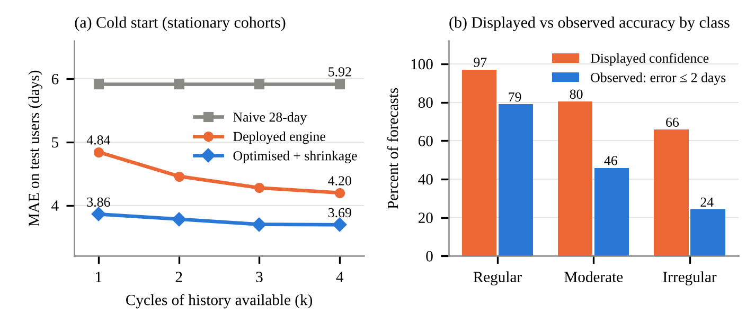
Figure 3. (a) Error versus the number of past cycles available. (b) Confidence displayed by the deployed engine versus the observed share of forecasts within two days, test users
Displayed confidence was optimistic in every class (Fig. 3b), 97% versus 78.9% observed for regular users and about 66% versus 24.2% for irregular users, an ECE of 31.6 points. Showing the training frequency of the user’s σ_{L} bin (82.6% for σ_{L} < 1 d down to 18.5% for ≥ 8 d) cut the test ECE to 3.6 points (1.6 under drift).
4.3 Implications and Limitations
The changes cost nothing on the device, and the card should state the chance of starting within two days rather than a “precision”. The evaluation is simulated (parameters follow [3, 4, 10]; skipped logging, contraception and life stage were not modelled), so w, τ and the table must be re-estimated on consented user data. Ovulation timing cannot be validated without hormonal or temperature markers [2].
CONCLUSION
Hard questionnaire floors, not recency weights, were the main avoidable error in SheSync’s forecasts: a tuned shrinkage prior cut error by 9–12% overall and about 20% at cold start, and a seven-entry table removed a 30-point overstatement of confidence. The tuned engine will next be validated on consented user data.
CONFLICT OF INTEREST
The authors declare no conflict of interest.
ACKNOWLEDGEMENT
An AI assistant (Claude, Anthropic) helped draft the text, run the simulation scripts and prepare the figures; the authors verified all content and take full responsibility for the chapter.
REFERENCES
- Epstein, D.A., Lee, N.B., Kang, J.H., Agapie, E., Schroeder, J., Pina, L.R., Fogarty, J., Kientz, J.A., & Munson, S.A. (2017). Examining menstrual tracking to inform the design of personal informatics tools. Proceedings of the 2017 CHI Conference on Human Factors in Computing Systems, 6876–6888.
- Worsfold, L., Marriott, L., Johnson, S., & Harper, J.C. (2021). Period tracker applications: What menstrual cycle information are they giving women? Women’s Health, 17, 17455065211049905.
- Bull, J.R., Rowland, S.P., Scherwitzl, E.B., Scherwitzl, R., Danielsson, K.G., & Harper, J. (2019). Real-world menstrual cycle characteristics of more than 600,000 menstrual cycles. npj Digital Medicine, 2, 83.
- Soumpasis, I., Grace, B., & Johnson, S. (2020). Real-life insights on menstrual cycles and ovulation using big data. Human Reproduction Open, 2020(2), hoaa011.
- Bozdag, G., Mumusoglu, S., Zengin, D., Karabulut, E., & Yildiz, B.O. (2016). The prevalence and phenotypic features of polycystic ovary syndrome: A systematic review and meta-analysis. Human Reproduction, 31(12), 2841–2855.
- Moglia, M.L., Nguyen, H.V., Chyjek, K., Chen, K.T., & Castaño, P.M. (2016). Evaluation of smartphone menstrual cycle tracking applications using an adapted APPLICATIONS scoring system. Obstetrics & Gynecology, 127(6), 1153–1160.
- Guo, Y., Manatunga, A.K., Chen, S., & Marcus, M. (2006). Modeling menstrual cycle length using a mixture distribution. Biostatistics, 7(1), 100–114.
- Bortot, P., Masarotto, G., & Scarpa, B. (2010). Sequential predictions of menstrual cycle lengths. Biostatistics, 11(4), 741–755.
- Oliveira, T., Bruinvels, G., Pedlar, C.R., & Newell, J. (2021). Modelling menstrual cycle length in athletes using state-space models. Scientific Reports, 11, 16972.
- Li, K., Urteaga, I., Wiggins, C.H., Druet, A., Shea, A., Vitzthum, V.J., & Elhadad, N. (2020). Characterizing physiological and symptomatic variation in menstrual cycles using self-tracked mobile-health data. npj Digital Medicine, 3, 79.
- Urteaga, I., Li, K., Shea, A., Vitzthum, V.J., Wiggins, C.H., & Elhadad, N. (2021). A generative modeling approach to calibrated predictions: A use case on menstrual cycle length prediction. Proceedings of Machine Learning Research, 149, 535–566.
- Efron, B., & Morris, C. (1975). Data analysis using Stein’s estimator and its generalizations. Journal of the American Statistical Association, 70(350), 311–319.
- Naeini, M.P., Cooper, G.F., & Hauskrecht, M. (2015). Obtaining well calibrated probabilities using Bayesian binning. Proceedings of the AAAI Conference on Artificial Intelligence, 29(1), 2901–2907.

* Address correspondence to Vyom Varshney, ABES Institute of Technology, Ghaziabad, Uttar Pradesh, India; Email Id-vyomvarshney2005@gmail.com

